Customer page

**هذه الصفحة شبيهة لموقع زد**

لرؤية وظائف عمل صفحة يمكنك زيارة موقع اكسباند كارت واستعمال اليوزر التالي:

<https://web.zid.sa/login>

**Email**: zaid@bzeed.com

**PW**: hnf89s8t

This page is very important because it includes all customers' data that bought from estore

When user enter to customer page for the first time, he/she do 1 of these option:

1. Create customer: can do it manually
2. Import customers: this option will help users if they had a big data

We need this page looks like (Expandcart)

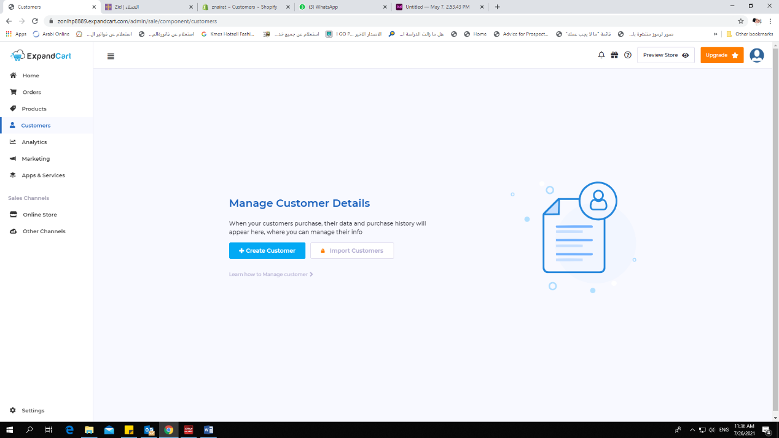

B. If the user need to create customer manually, he/she must enters this information:

**- Name**

**- Email** (optional) because most customer in Middle East don't have an email or forget what is it

**- Phone**

**- Country + City**

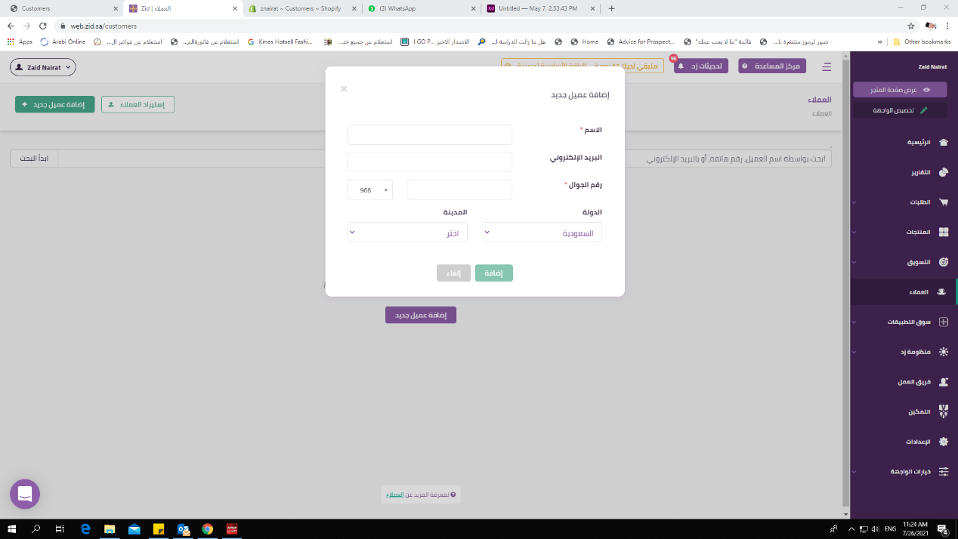

C. if there were customers in customer page, the page will look like this:

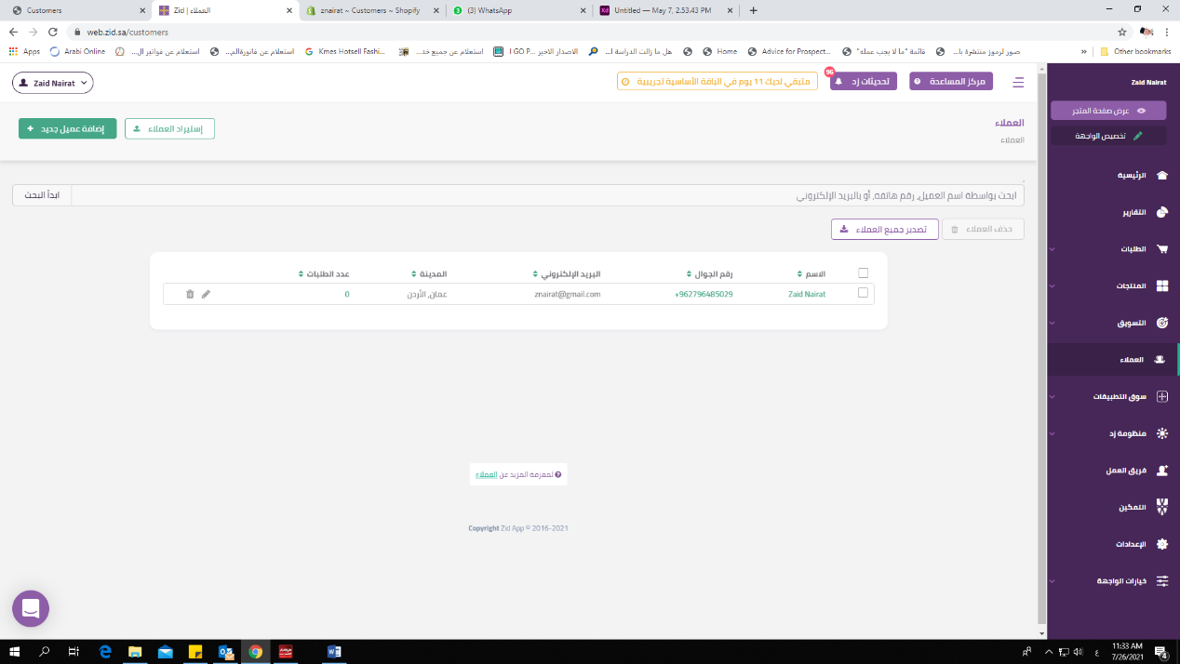

Includes:

* **Customer Name:**
* **Phone**
* **Email**:
* **City**
* **No Of order**: if user click the number he/she will go directly to order page that includes all order data for customer

Continue order page